D92 Upgrade Pack for OMSI
By PoweredByCNG & krtz07

INTRODUCTION
Thank you for downloading the D92 Upgrade Pack for OMSI. This Upgrade pack was developed in response to a perceived need for more modern powertrain and driveline combinations for such maps as Spandau Modern and Great Grundorf. This project was developed with realism in mind and therefore much time has been spent accurately calibrating the engines and gearboxes for realistic performance.

FEATURES
This Upgrade Pack will provide you with the following combinations for the MAN SD 202:
- MAN SD 202 – D92 with MAN D2566 UH (192 PS) engine and Voith D851.2 3-speed automatic gearbox (original configuration included with OMSI)
- MAN SD 202 – D92 with MAN D2866 LUH (260 PS) engine and Voith D863.3 3-speed automatic gearbox with three gearshift programs (Economy, Balanced, Power)
- MAN SD 202 – D92 with MAN D2866 LUH (260 PS) engine and Voith D864.3E 4-speed automatic gearbox with three gearshift programs (Economy, Balanced, Power)
REQUIREMENTS
The only requirement for the Upgrade Pack is an existing installation of OMSI – The Bus Simulator. Please note that it is highly recommended that you upgrade your installation with the OMSI v1.01 patch prior to installing this Update Pack.

INSTALLATION
To install the Upgrade Pack, you will need to extract the contents of the RAR file (with a program such as WinRAR) into the following directory:
X:\OMSI-Path\vehicles\MAN_SD202
Where ‘X:\OMSI-Path’ represents the location of your main OMSI directory.
To confirm that you have installed the Upgrade Pack correctly, start OMSI and make sure that you can see four D92 variants in the bus selection window.

TECHNICAL SPECIFICATIONS
The technical specifications of the new powertrain and drivelines (as calibrated for the simulation) are described below.

ENGINE
Make | MAN
Model | D2866 LUH 23
Emissions control | Euro III with cooled exhaust gas recirculation (EGR)
Design | In-line
No. of cylinders | 6
Arrangement | Horizontal
Induction | Turbocharged & charge-air cooled
No. of valves | 24 (Four per cylinder)
Combustion cycle | 4-stroke direct injection diesel
Bore | 128 mm
Stroke | 155 mm
Displacement | 11967 cm³
Compression ratio | 19:1
Maximum power | 191 kW (260 PS)
at | 1,900 rpm
Maximum torque | 1,050 Nm
at | 1,000 - 1,400 rpm
Torque rise | 9%
Governed speed | 2,200 rpm

PERFORMANCE DATA
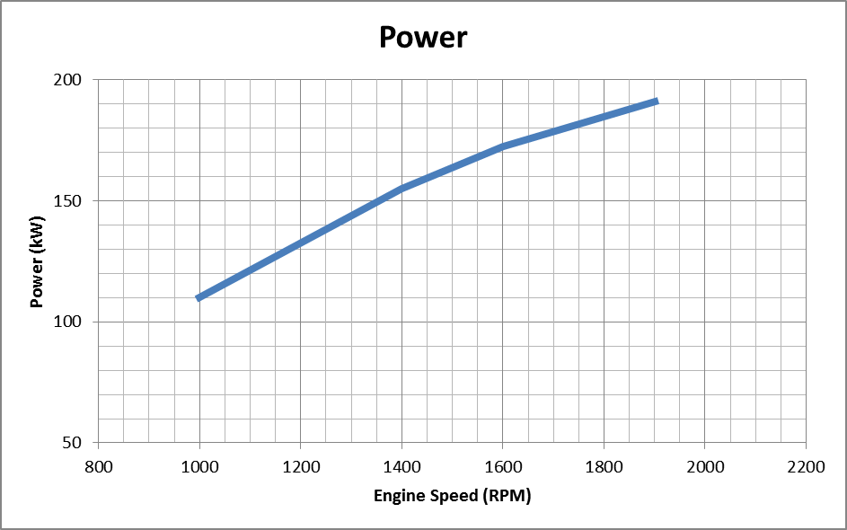
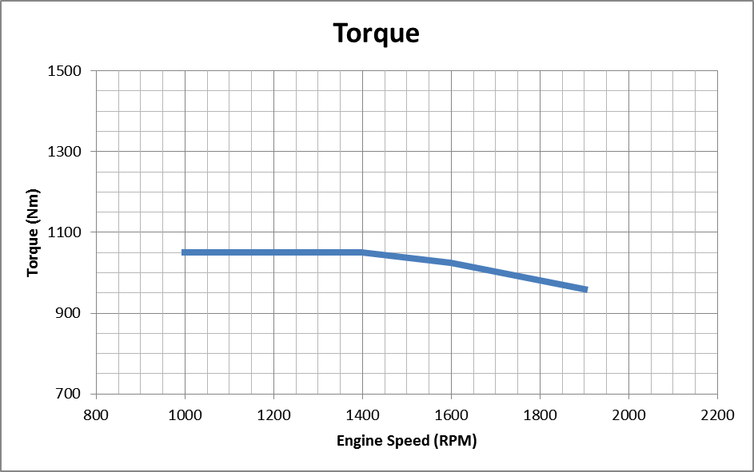

TRANSMISSIONS
Model | Voith D851.2 |  | Voith D863.3E | Voith D864.3E
Ratios
1st | 5.05* |  | 5.05* | 5.05*
2nd | 1.36 |  | 1.36 | 1.36
3rd | 1.00 |  | 1.00 | 1.00
4th | - |  | - | 0.73
Reverse | 4.30 |  | 4.30 | 4.30
Final drive ratio | 5.74:1 |  | 5.74:1 | 5.74:1
Road speed | 72 km/h |  | 72 km/h | 97 km/h
* Differential torque converter

FINAL WORDS
Firstly, I would like to extend a huge thanks to Kyle (krtz07) who originally developed the script for a 4-speed automatic transmission. Without his hard work, this Upgrade Pack would not be possible.
Secondly, I would like to thank Marcel Kuhnt and Rüdgier Hülsmann for producing the quality piece of software that we know as OMSI. OMSI was the breakthrough that the bus enthusiast scene needed – a simulator (*NOT* a game) that aims to provide the prospective user with the most realistic experience possible. I would also like to thank Marcel, Rüdgier and the team of Administrators and Moderators for providing the OMSI Forum – a place for the OMSI community to share their experiences and developments.
Thirdly, I would like to thank the staff at MAN AG and Voith AG for providing me with valuable data for use with this Upgrade Pack.
And last but not least, I would like to once again thank you for downloading this Upgrade Pack. I sincerely hope that you enjoy the OMSI experience with the expanded options that this Upgrade Pack will provide you with. I would like to request that if you have any comments or recommendations, to make yourself known in the Script Programming (English) section of the OMSI Forum where I have a dedicated thread for this Upgrade Pack. The address for this thread (as of 19/05/2011) is as follows:
http://omnibussimulator.forumieren.com/t3242-released-man-d92-upgrade-pack-landmark-release-v30
Please keep an eye out on this thread for future developments.

CONTACT
David Lee (PoweredByCNG)
Perth, Western Australia
E-mail: poweredbycng@gmail.com
Windows Live: tp1776@hotmail.com
Skype: poweredbycng
ICQ: 35-028-220

